Practical 1: Introduction to React and Component Architecture
Objective | To set up a React development environment using Vite and build a static UI using independently structured, reusable components.
Problem Statement | • Create a React application using Vite for a student portfolio page.  • The application must include at least 4 reusable components: Header, About, Skills, and Footer.  • Each component must be independently structured and composed into a single-page layout.  • No logic or JSX should be duplicated across components.  • Props must be used to pass at least one piece of data into a minimum of 2 components.
Project Structure | student-portfolio/  └── src/  ├── App.jsx  └── components/  ├── Header.jsx  ├── About.jsx  ├── Skills.jsx  └── Footer.jsx
Implementation | 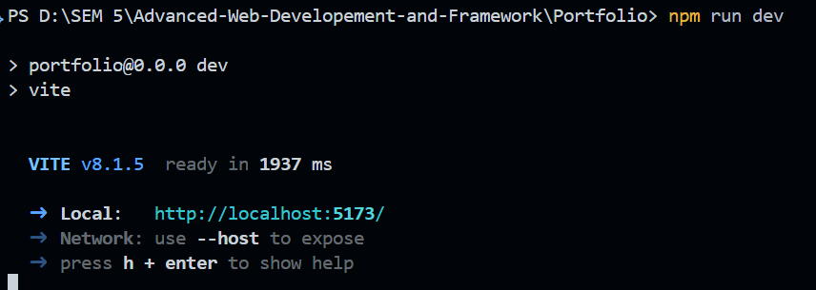  To Create folder with react and JavaScript write the following command:  npm create vite@latest student-portfolio -- --template react  cd student-portfolio  npm install  npm run dev  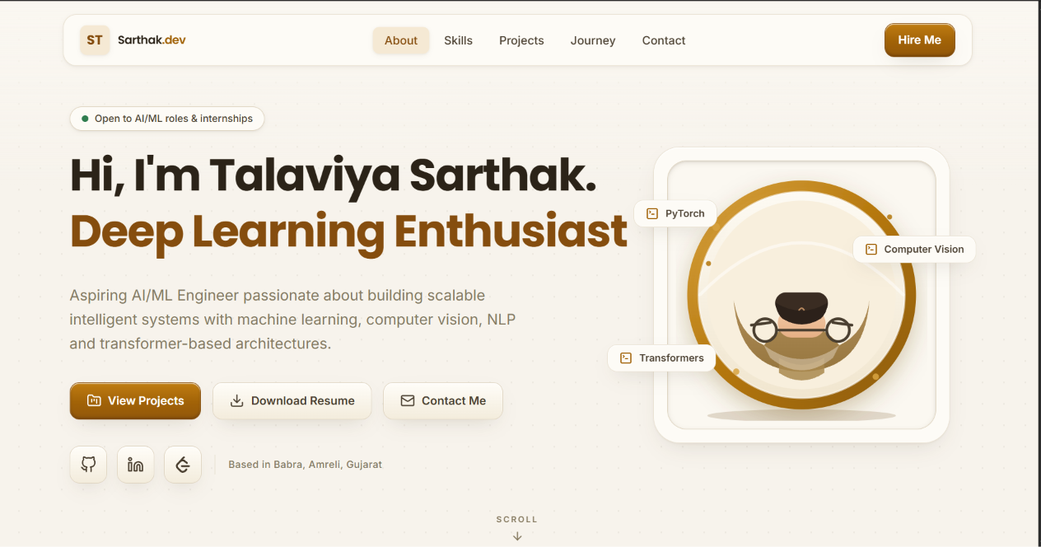  Header.jsx:  function Header({ name, role }) {  return (  <header className="flex min-h-screen w-full items-center justify-center px-4 py-0 text-center">  <div className="w-full max-w-5xl rounded-2xl border border-sky-300/30 bg-slate-900/70 p-8 shadow-2xl backdrop-blur-sm">  <p className="m-0 text-xs uppercase tracking-[0.18em] text-slate-300">Student Portfolio</p>  <h1 className="my-2 text-4xl font-bold text-slate-50 md:text-6xl">{name}</h1>  <p className="m-0 text-lg font-semibold text-cyan-300">{role}</p>  </div>  </header>  )  }  export default Header  About.jsx:  function About({ bio, education }) {  return (  <section  className="rounded-2xl border border-sky-300/30 bg-slate-900/70 p-6 shadow-2xl backdrop-blur-sm"  aria-labelledby="about-title"  >  <h2 id="about-title" className="text-2xl font-semibold text-slate-100">  About Me  </h2>  <div className="mt-4 space-y-3">  <p className="rounded-xl border border-slate-600/60 bg-slate-800/70 p-4 text-slate-200">{bio}</p>  <p className="rounded-xl border border-cyan-400/40 bg-slate-800/70 p-4 text-slate-300">{education}</p>  </div>  </section>  )  }  export default About  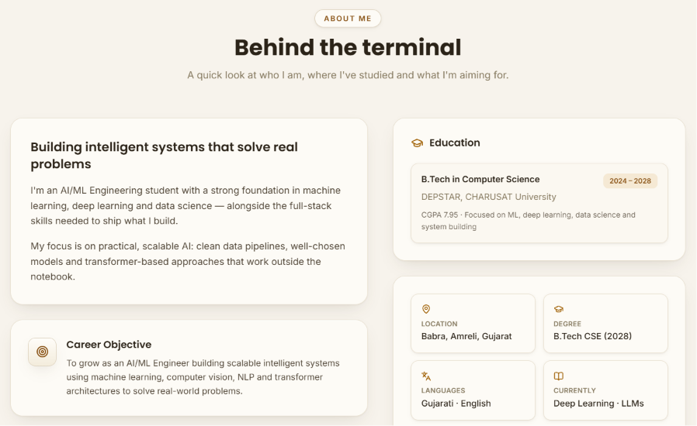  Skills.jsx:  function Skills({ skills }) {  return (  <section  className="rounded-2xl border border-sky-300/30 bg-slate-900/70  p-6 shadow-2xl backdrop-blur-sm"  aria-labelledby="skills-title"  >  <h2 id="skills-title" className="text-2xl font-semibold text-slate-100">  Skills  </h2>  <ul className="mt-4 grid list-none grid-cols-2 gap-3 p-0 md:grid-cols-3">  {skills.map((skill) => (  <li  key={skill}  className="rounded-xl border border-cyan-300/40 bg-slate-800/80 px-3 py-3 text-center font-semibold text-cyan-100"  >  {skill}  </li>  ))}  </ul>  </section>  )  }  export default Skills  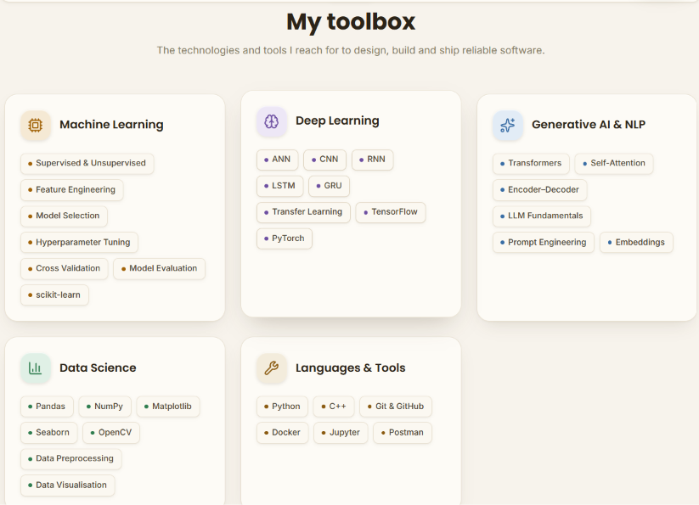  Footer.jsx:  function Footer({ name, year }) {  return (  <footer className="mt-auto w-full border-t border-sky-300/30 bg-slate-950/70">  <div className="mx-auto w-full max-w-5xl px-4 py-4 text-center text-sm text-slate-300">  <p className="m-0">  © {year} {name}. Built with React + Vite.  </p>  </div>  </footer>  )  }  export default Footer  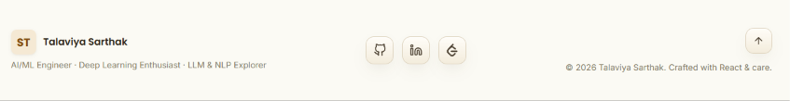  App.jsx:  import Header from './components/Header'  import About from './components/About'  import Skills from './components/Skills'  import Footer from './components/Footer'  function App() {  const portfolio = {  name: 'Sarthak Talaviya',  role: 'B.Tech Student | Frontend Enthusiast',  bio: 'I am a third-year engineering student passionate about creating clean and useful web interfaces. I enjoy solving practical problems with React and learning new technologies through projects.',  education: 'B.Tech in Computer Science, Expected Graduation: 2028',  skills: ['HTML5', 'CSS3', 'JavaScript', 'React', 'Vite', 'Git'],  }  const currentYear = new Date().getFullYear()  return (  <div className="min-h-screen flex flex-col">  <Header name={portfolio.name} role={portfolio.role} />  <main className="mx-auto w-full max-w-5xl space-y-4 px-4 py-8">  <About bio={portfolio.bio} education={portfolio.education} />  <Skills skills={portfolio.skills} />  </main>  <Footer name={portfolio.name} year={currentYear} />  </div>  )  }  export default App
Output | GitHub Repo along with commands:  git init  git add .  git commit -m "Initial portfolio with Header, About, Skills, Footer components"  git remote add origin https://github.com/Talaviya-Sarthak/Advance-web-developement-and-framework.git  git branch -M main  git push -u origin main
Conclusion | Through this practical, a React development environment was successfully set up using Vite, and a working portfolio UI was built using four independently structured, reusable components. Props were used to pass dynamic data (name and skillList) into child components, reinforcing the core React concepts of component composition and unidirectional data flow.

